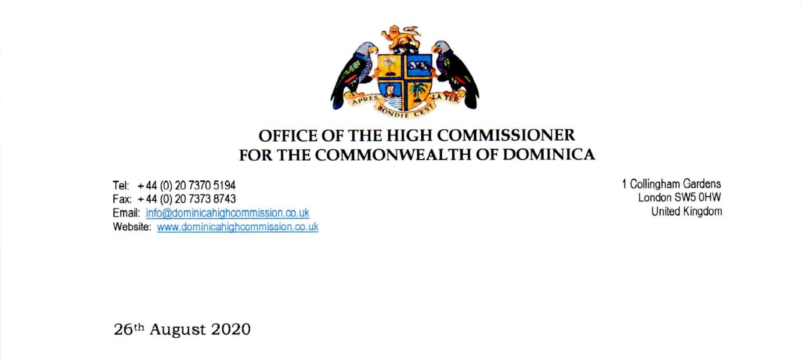

To Whom It May Concern:

The High Commission for the Commonwealth of Dominica is pleased to endorse the Dominica Secondary School Supporters Association (DASSSA) . Funds raised by DASSSA primarily go to give much needed support to secondary school children in Dominica.

